Cinnamon Doughnut Puffs
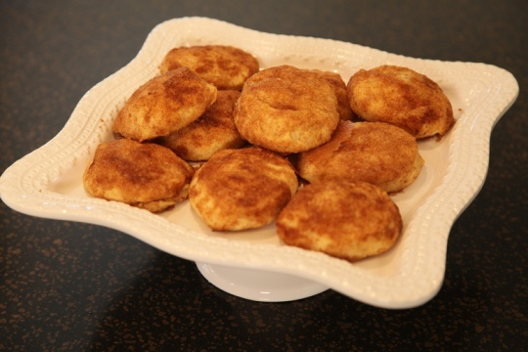2
2 Tablespoons Cinnamon
1 cup sugar
½ cup butter, melted
1 8 oz tube refrigerated biscuits ( not flaky kind)

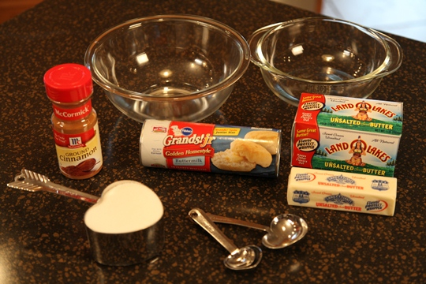
Directions:
Mix the cinnamon and sugar together in a medium bowl. Place the melted butter in a separate bowl. Separate the biscuits. Dip biscuits into butter, then into cinnamon & sugar mixture. Place on an ungreased baking sheet.
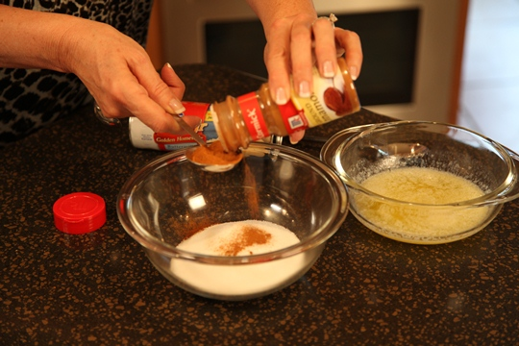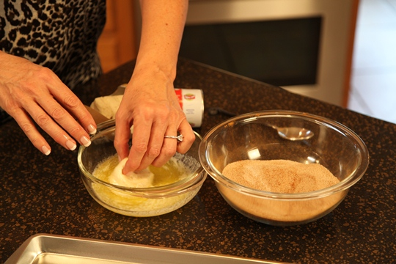

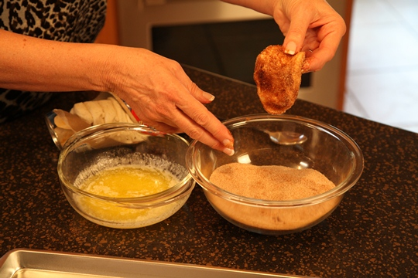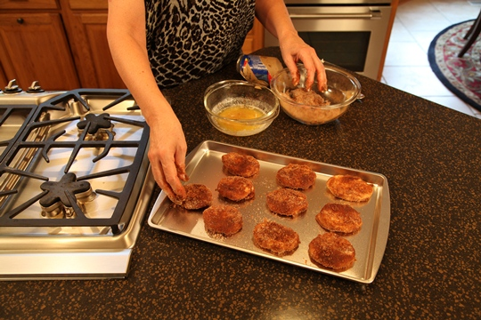
Bake at 375 degrees for 12 to 15 minutes, until golden.
Makes 10 Cinnamon Doughnut Puffs

