Crockpot Spaghetti
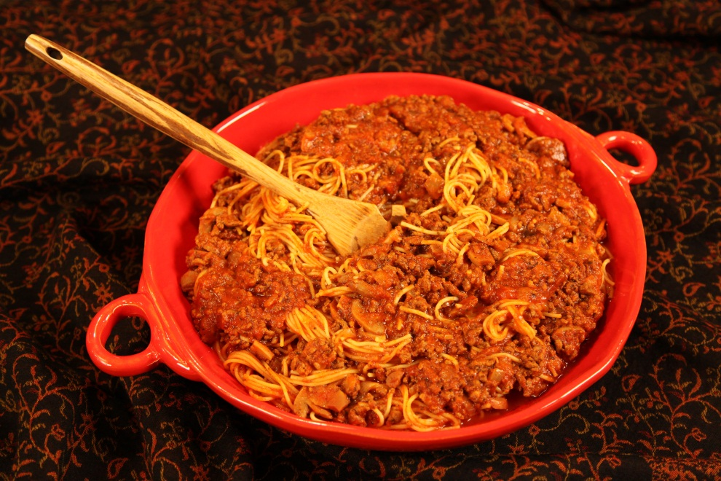
2 pounds ground chuck – browned and drained
1 cup onion, chopped
3 cloves garlic – minced
29 ounce can tomato sauce
3 teaspoons Italian seasoning
1 ½ teaspoons salt
¼ teaspoon pepper
8 ounce can sliced mushrooms, drained
6 cups tomato juice
16 ounce package dry spaghetti – broken in half
Grated Parmesan cheese , optional for serving
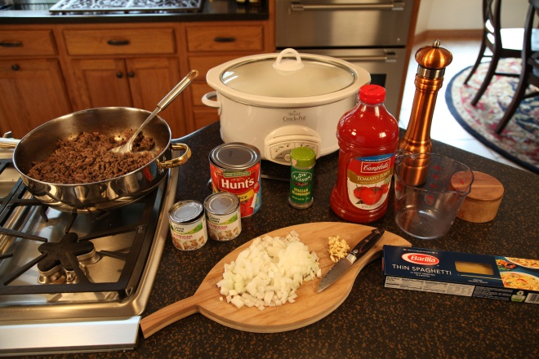

Place all ingredients except the dry spaghetti and the Parmesan cheese in a 6 quart slow cooker. Cover and cook on LOW 6 to 8 hours or HIGH 3 to 5 hours.

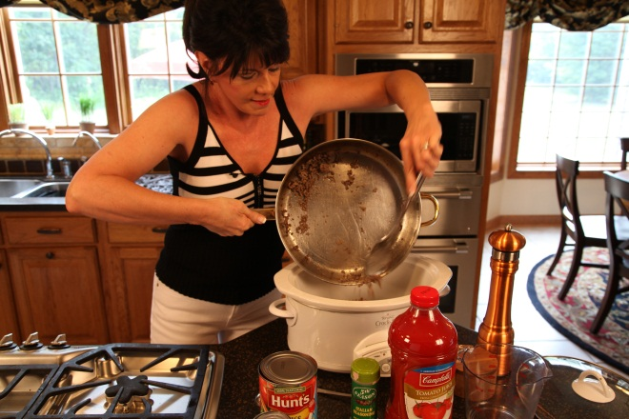
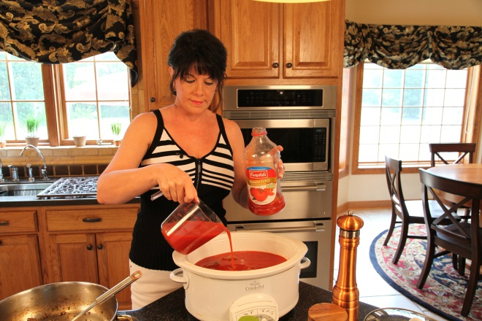

Turn to HIGH during the last 30 minutes and stir in the dry spaghetti. If you use anything other than thin spaghetti, you may need to continue cooking another 10 minutes.

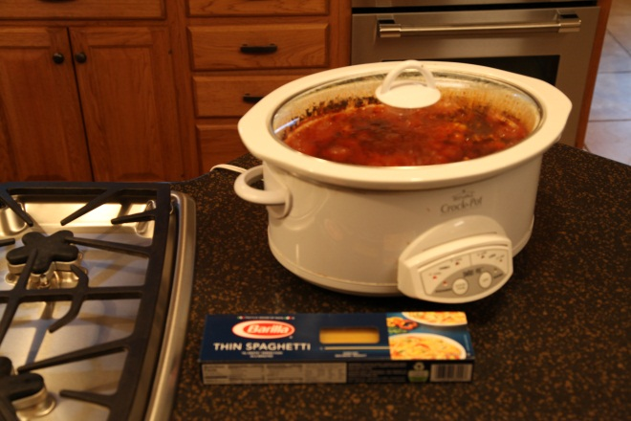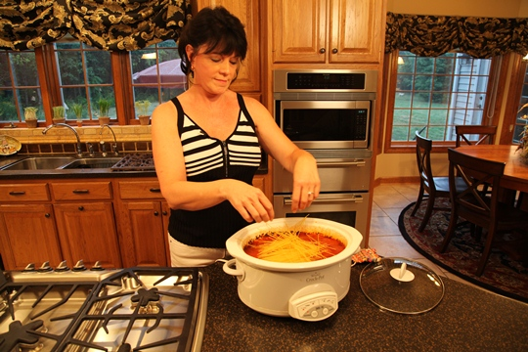
Remember, let’s make life special by sharing great food with our family and friends! Enjoy!

