Success Secret: Bacon for a Bunch
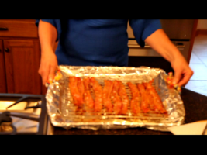
I LOVE bacon!!! But, cooking bacon for a bunch can be difficult…unless you use my success secret:
Preheat the oven to 400 degrees.
Lay a wire cooling rack into a foil lined rimmed cookie sheet.
Lay the bacon slices on the rack. You should be able to cook 10 to 12 slices of bacon. If you need to cook more, use two baking sheets.
For a pretty presentati9on, scrunch the bacon slightly to make a ribbon effect.
Bake for 15 to 18 minutes. Adjust the baking time if you are using thicker slices of bacon.

